Dobot Magician Project

Daniel Tobón, *2126550*, *IEE  
Universidad Autónoma de Occidente*

*Abstract*—In the present report of the Dobot Magician Robot is realized, its history, its applications, its design in Solidworks software, which will be implemented in the Ubuntu operating system, creating an urdf file that will be the code that contains the information of the robot in terms of its structure, using ROS software (Robot Operating System) and be displayed on the Rviz platform.

**General Objective:**

* **Model the Dobot Magician Robot in ROS software using the Rviz platform.**

**Specific Objectives:**

* **Take measurements of the dimensions of the physical robot for the 3D model.**
* **3D modeling of the Dobot Magician Robot in Solidworks software with its real measurements.**
* **Make the description in an URDF file that contains the code of the Dobot Magician Robot.**

*Index Terms*—Dobot, ROS, Urdf.

# INTRODUCTION

Shenzhen Yueliang Technology [1] is a company dedicated to development robot arm solution in China. Dobot is the first generation of robot arm debuted in 2015 in the worldwide.

Dobot Magician (see figure 1) integrates 3D printing, laser engraving, painting and writing. Dobot Magician in Rviz

The Dobot Magician manual contains the technical specifications, as the material and the turning speed of each joint. Table 1 shows the most important technical specifications, including the selection of the pen for drawing and writing as final effector.

TABLE I

Specifications

|  |  |
| --- | --- |
| Description | Value |
| Number of axes | 4 |
| Payload  Max.reach | 500 g  320 mm |
| Joint 1 base range | -90° to +90° |
| Joint 2 rear arm range | 0° to +85° |
| Joint 3 forear arm range | -10° to +95° |
| Joint 4 rotation servo | +90° to -90° |
| Joint 1 speed | 320°/s |
| Joint 2 speed | 320°/s |
| Joint 3 speed | 320°/s |
| Joint 4 speed | 480°/s |
| Net weight | 8.0 kg |
| Base dimension | 158 mm x 158 mm |
| Materials | Aluminum alloy 6061 |
| Pen diameter | 10 mm |
| Gripper range  Gripper drive type  Gripper force | 27.5 mm  Pneumatic  8N |

The objective of modeling the robot in urdf format is to be able to visualize the robot in Rviz as shown in figure 4.

*Figure 4. Dobot Magician Robot in Rviz.*

The Dobot Magician manipulator has 6 degrees of freedom; That is, in 3D modeling of the robot it is necessary to generate 6 links with their respective dimensions in the archive urdf that describes the robot. The first step is to create the robot package in the catkin_ws folder. To do this, in the terminal of ubuntu catkin_create_pkg "*package name*" is used to create the package associated with the Dobot Magician Robot. Once the package is created, it must be built in the workspace catkin_ws; the catkin_make command allows you to build the Dobot Magician Robot package in catkin_ws. The figure 5 shows the package dobot_magician_pkg with the urdf, meshes and launch folders.

*Figure 5. Dobot magician package.*

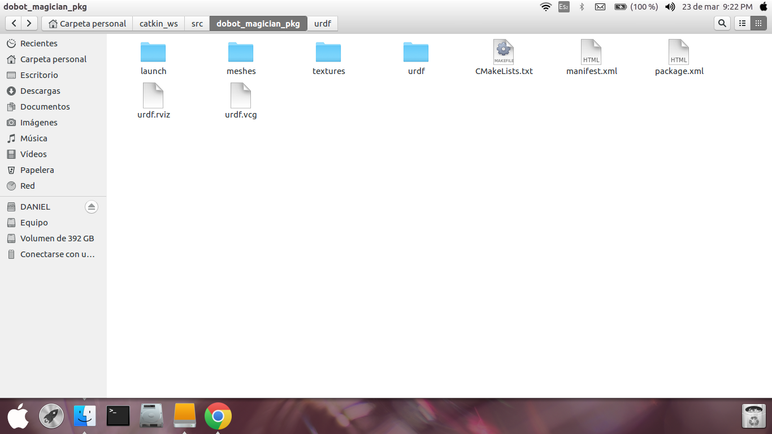

Inside of Dobot Magician package are 3 different sub-packages; urdf is the package that contains the description of the robot in a file in XML format, meshes is a folder that contains the robot geometry shell and the launch folder, it contains the “.launch” files that call the ROS Nodes. However, in order to be able to size each robot link in the urdf model, the measurements of each link were taken with a 50 division footprint on the nonio scale; The length and the thickness. The angles were measured with gauges in mm for radios and for those measures difficult to reach, a conventional meter was used. The description of the robot in the urdf file is shows in the figure 6.

*Figure 6. Dobot Magician urdf file.*

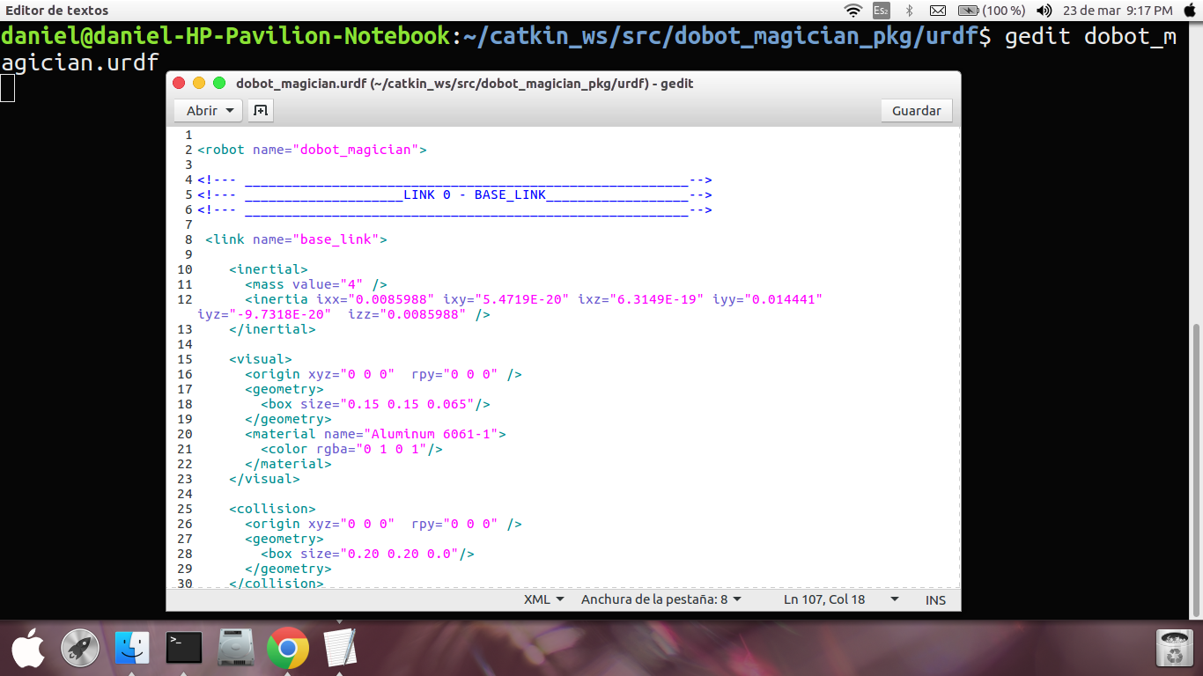

A part of the code is shown below:

<robot name="dobot_magician">

<!--- ________________________________________________________-->

<!--- ____________________LINK 0 - BASE_LINK__________________-->

<!--- ________________________________________________________-->

<link name="base_link">

<inertial>

<mass value="4" />

<inertia ixx="0.0085988" ixy="5.4719E-20" ixz="6.3149E-19"

iyy="0.014441" iyz="-9.7318E-20"izz="0.0085988" />

</inertial>

<visual>

<origin xyz="0 0 0" rpy="0 0 0" />

<geometry>

<box size="0.15 0.15 0.065"/>

</geometry>

<material name="Aluminum 6061-1">

<color rgba="0 1 0 1"/>

</material>

</visual>

<collision>

<origin xyz="0 0 0" rpy="0 0 0" />

<geometry>

<box size="0.20 0.20 0.0"/>

</geometry>

</collision>

</link>

<!--- ________________________________________________________-->

<!--- ____________________JOINT 1_____________________________-->

<!--- ________________________________________________________-->

<joint name="joint_1" type="revolute">

<parent link="base_link"/>

<child link="link_1"/>

<origin xyz="0 0 0.1"/>

<axis xyz="0 0 1" />

<limit effort="300" velocity="0.1" lower="-3.14" upper="3.14"/>

<dynamics damping="50" friction="1"/>

</joint>

<!--- ________________________________________________________-->

<!--- ____________________LINK 1______________________________-->

<!--- ________________________________________________________-->

<link name="link_1">

<visual>

<geometry>

<box size="0.0495 0.06 0.104"/>

</geometry>

<origin rpy="0 0 0" xyz="0 0 -0.025"/>

<material name="Aluminum 6061-2">

<color rgba="1 0 0 1"/>

</material>

</visual>

<collision>

<geometry>

<box size="0.06 0.08 0.2"/>

</geometry>

<origin rpy="0 0 0" xyz="0 0 -0.025"/>

</collision>

<inertial>

<mass value="0.096"/>

<inertia ixx="0.00011245" ixy="-6.1285E-12"

ixz="-2.3175E-12" iyy="3.1935E-05"

iyz="7.882E-06" izz="0.00013863"/>

</inertial> </link> </robot>

Each link is composed of three tags; *<visual>* describes the link geometry, coordinate origin, and material. The *<inertial>* tag describes the inertia characteristics of the link. These values are specific to the geometry of each link. Because the model of the robot was also made in Solidworks, it is a tool that provides that type of information. Finally, the *<collision>* tag describes a geometry that makes up the link, generally of the same shape and dimensions, which allows to determine the possible collisions of the element with another.

Once created the Dobot Magician package and the urdf file with the description of the model, you can run the setup.bash in the devel folder of the catkin_ws to be able to view it in Rviz as follows. In the terminal of ubuntu:

$ source devel/setup.bash

Is executed as shown in figure 7. After it has been executed, the model of the robot is visualized in Rviz with the command line roslaunch "name of the Package ""launch file ".

*Figure 7. Running the robot model in Rviz.*

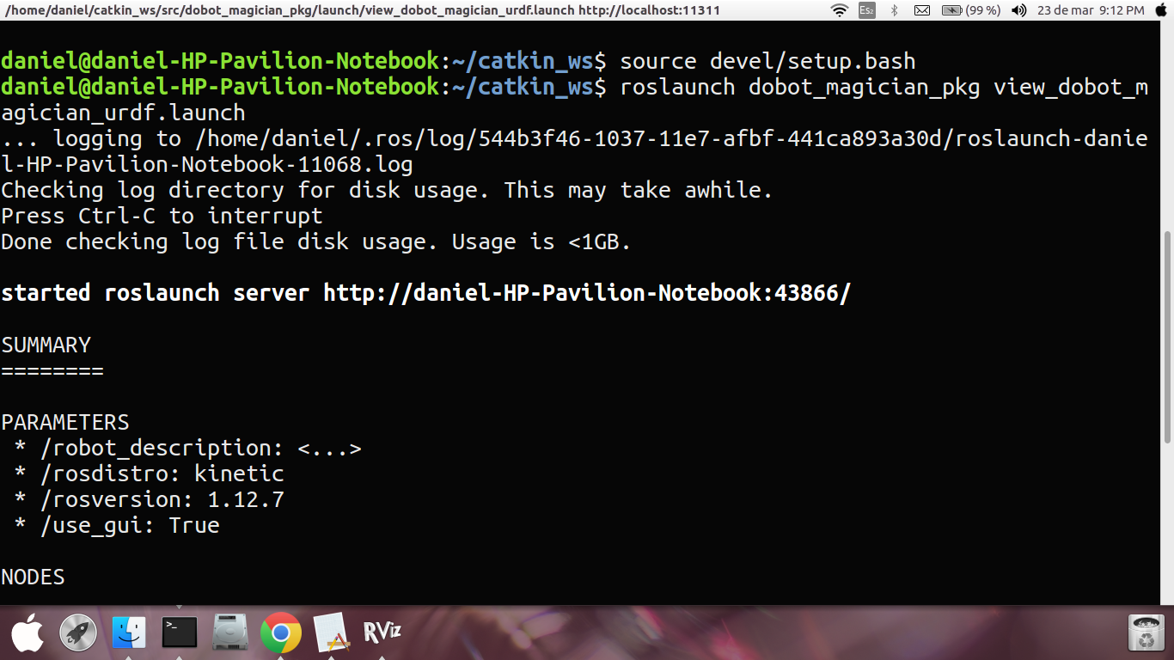

After the Rviz has been executed correctly, the model of the robot can be visualized. The figure 8, shows the model in Rviz of the Dobot Magician Robot with the node joint_state_publisher which allows to modify the articular behavior of each pair of links.

*Figure 8. Dobot magician robot model in Rviz.*

Rviz allows to visualize the model of robot, the axes of rotation, the origins of each frame of reference. The following figures shows other views of the model in Rviz.

*Figure 9. Dobot magician robot model view 1.*

*Figure 10. Dobot magician robot model view 2.*

As you can see, the robot has 6 degrees of freedom and the end effector is effectively the pen selected for drawing and writing. SolidWorks is a CAD software for 3D mechanical modeling, currently developed by SolidWorks Corp [4]. The program allows you to model parts and assemblies and extract them from both technical drawings and other information needed for production. The 3D model of the robot can be seen in the figure 11.

*Figure 11. Robot model of Dobot Magician in Solidworks 2016.*

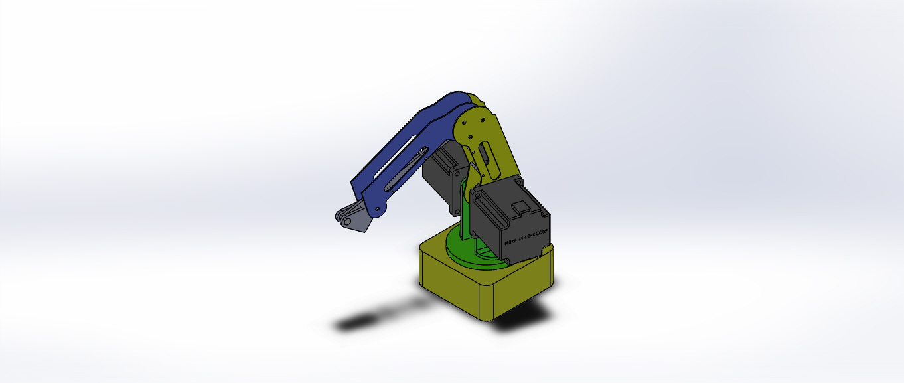

Alternatively, Solidworks allows to perform static analysis to determine faults and deformations in the material used for the design of a mechanical element. Figure 12 shows the static analysis applying an 8N force on the final effector.

*Figure 12. Static analysis of the Dobot Magician in Solidworks.*

When the modeling requirements of the robot require a geometry more similar to the real model, you can take advantage of the model made in Solidworks by exporting the pieces in .STL format. STL is a native format file to the stereolithography CAD software (STL file format, wikipedia). This format allows the visualization of each link that composes the robot with a more elaborate aspect; For this laboratory had problems in loading the STL files in Rviz because it did not allow the visualization of the geometry in the program, for this, it was necessary to convert each STL file in the DAE format that brings the modeling program by default CAD, Blender. Once the pieces are in the format that Rviz allows to display, you only need to define the geometry of each link with the <mesh> tag and indicating the address of the .DAE file that refers to that link.

A part of the code is shown below where the green line shows how to indicate the geometry of the link made in Solidworks in .dae format and located in the meshes folder of the package dobot_magician_pkg

<link name="base_link">

<visual>

<origin xyz="0 0 0" rpy="0 0 0" />

<geometry>

<mesh filename="package://dobot_magician_pkg/meshes/Dobot_magician_DAE/base.dae"/>

</geometry>

<material name="Aluminum 6061">

<color rgba="1 1 1 1" />

</material>

</visual>

<inertial>

<origin xyz="0 0 0" rpy="0 0 0" />

<mass value="3.913" />

<inertia ixx="0.0085988" ixy="9.7318E-20" ixz="6.3149E-19" iyy="0.014441" iyz="-5.4725E-20" izz="0.0085988" />

</inertial>

<collision>

<origin xyz="0 0 0" rpy="0 0 0" />

<geometry>

<mesh filename="package://dobot_magician_pkg/meshes/Dobot_magician_DAE/base.dae"/>

</geometry>

</collision>

</link>

The urdf model of the Dobot Magician can be visualized in Figures 13 and 14.

*Figure 13. Robot model of Dobot Magician from Solidworks in Rviz.*

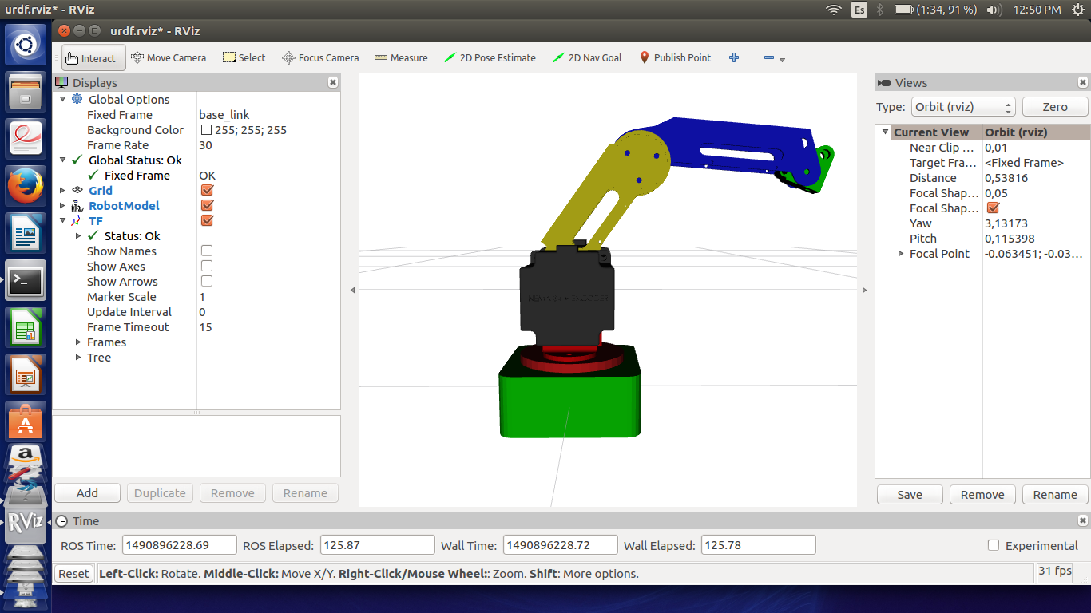

*Figure 14. Robot model of Dobot Magician from Solidworks in Rviz.*

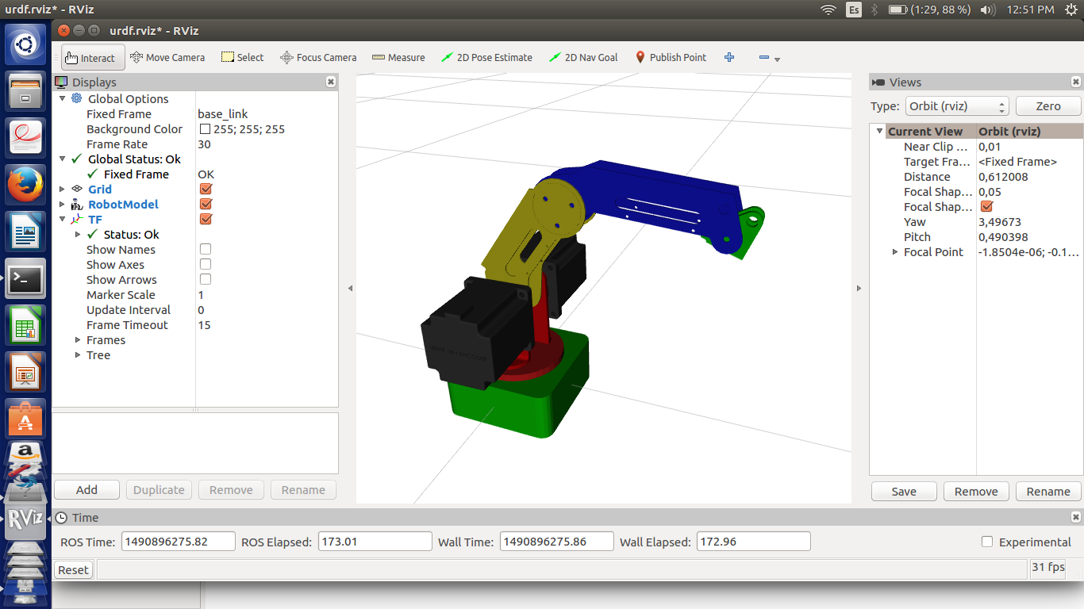

To finalize, with the objective of giving a final finish and a better look at the model of the robot, a rendering was applied obtaining the final 3D model of the robot as shown in figure 15.

*Figure 15. Rendered of the Dobot Magician robot model.*

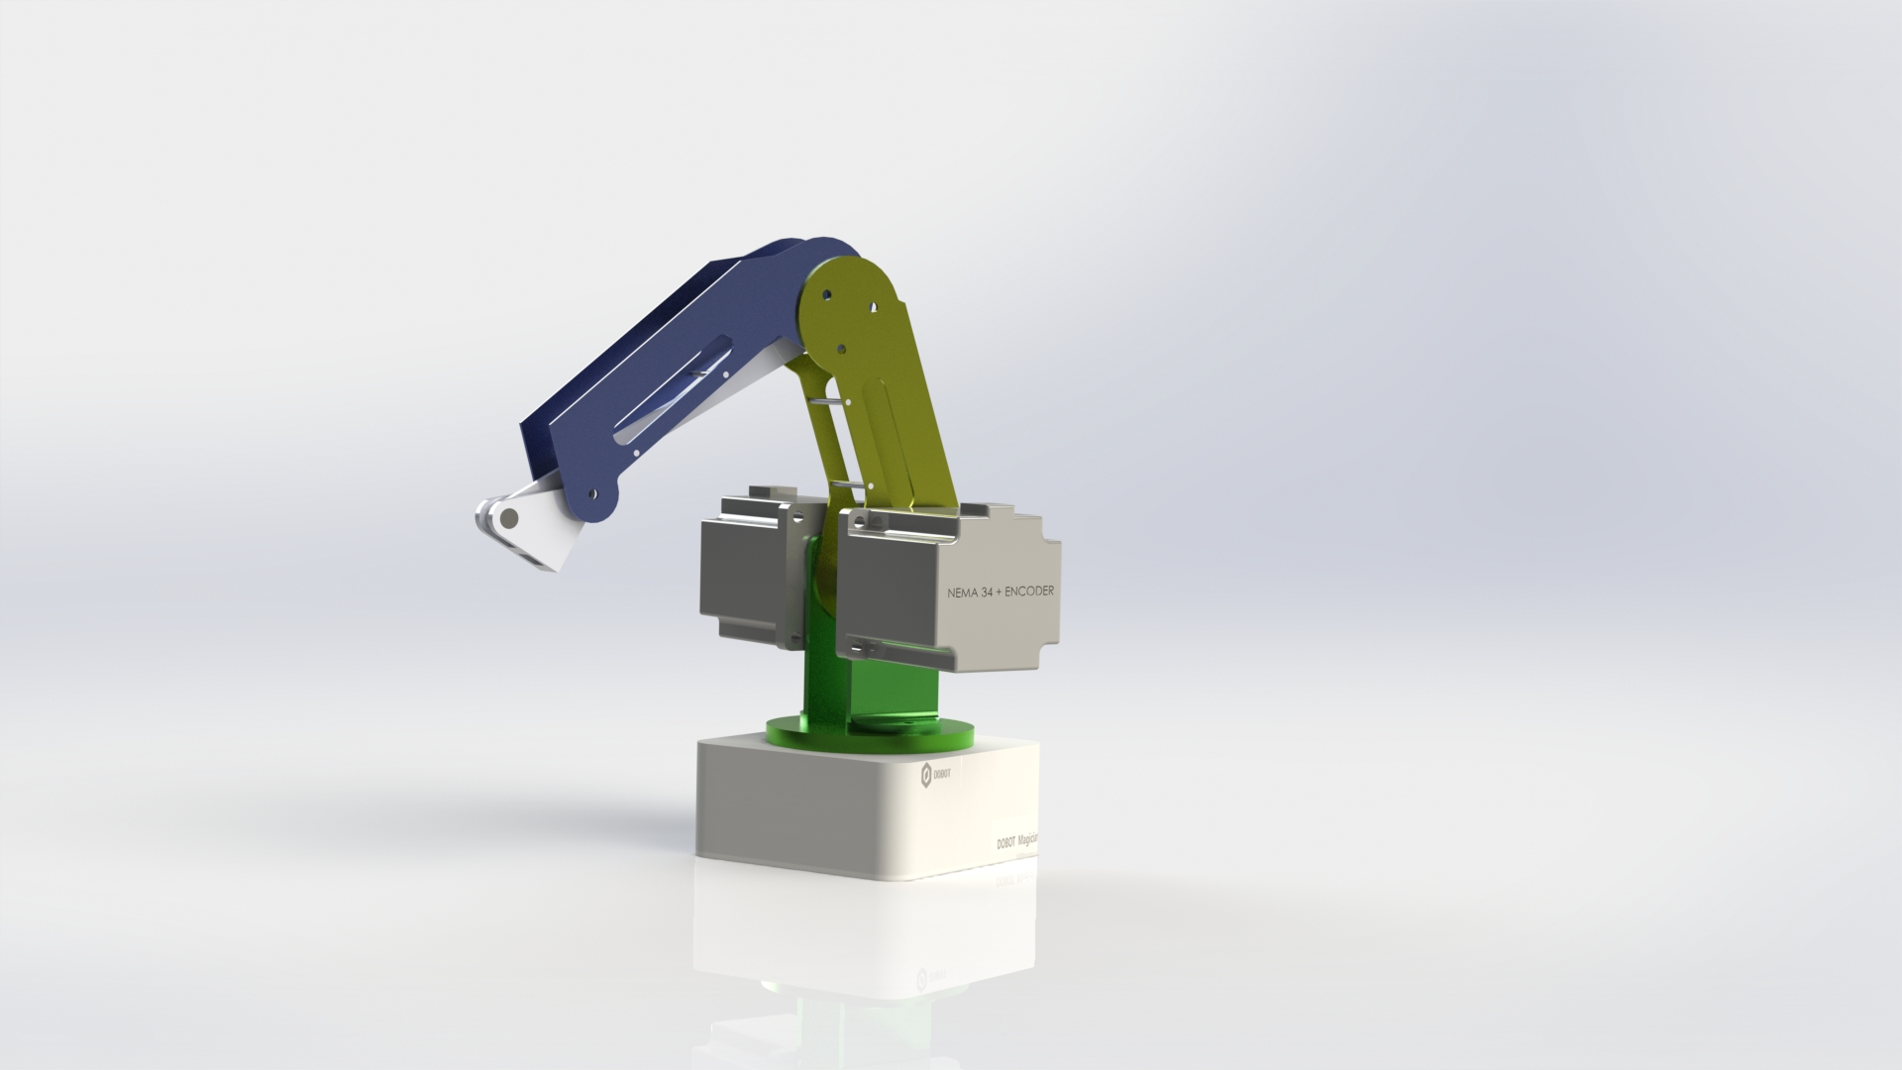

*Figure 16. Dobot Magician real model.*

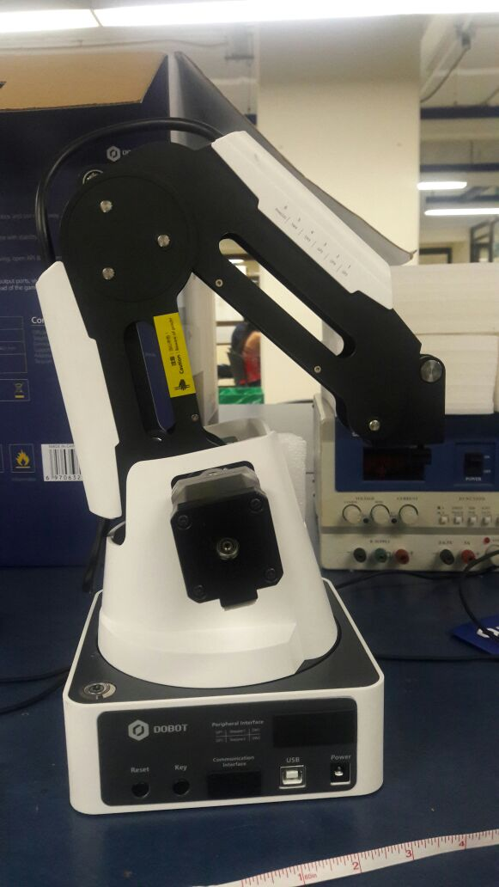

# Conclusion

The design and modeling of a robot using ROS is achieved by specifying and describing the geomechanical characteristics of the robot; To do this, there is a package containing the files with the robot descriptions. Depending on the application and the type of complexity that the robot has to design, you can model the robot with urfd or xacro file. The difference is that urdf files can model a simple robot that contains few links and joints; When the design requires more complexity it is appropriate to use xacro since it allows to use macro functions that allow to reduce the code of implementation, making more effective the design.

When passing the parts of the robot to the urdf you have to take into account the origins of the joints and the links. This is because they are not fixed as in the file of solidworks, for this you have to place the corresponding origin of each element, taking into account who is the father and son.

References

1. Dobot Magician. (online), available in http://dobot.cc/dobot-magician/product-overview.html. (2017) Shenzhen Yuejiang Technology. Interface of Dobot Magician software. Dobot magician user manual, Pag.12
2. Letin Joseph, Mastering ROS for Robotics Programming*.* Birmingham B3 2PB, UK. ISBN 978-1-78355-179-8.
3. Solidworks, Dassault Systemes - SolidWorks Corporation (2017). (online), available in https://es.wikipedia.org/wiki/SolidWorks